ANTI-SLEEP ALARM USING ARDUINO NANO

Rajdeep Saha 25,

**

*Department of Electronics and Communication Engineering,*

*Supreme Knowledge Foundation Group of Institutions*

**Technical Report On**

**Anti Sleep Alarm Using Arduino NANO**

Submitted in the partial fulfillment of the requirement to

Soft Skill Development Lab

HS-HU 481

**Under the Guidance of**

Mr. Anirban Neogi

Assistant Professor

ECE Dept.

**Submitted by**

Rajdeep Saha

University Roll Number

25300322025

**DATE OF SUBMISSION**

26th May 2023

**CERTIFICATE**

This is to certify that this project report entitled” **Anti Sleep Alarm Using Arduino NANO”** submitted in requirement to Soft Skill Development Lab ( HS-HU 481 )is a bonafide record of the study carried out by “**Rajdeep Saha”**  under our supervision from **“23rd February 2023**” to “ **20th May 2023”**

SIGNATURE SIGNATURE

ANIRBAN NEOGI JHULAN DASGUPTA

ASSISTANT PROFESSOR ASSISTANT PROFESSOR

DEPT.OF ELECTRONICS DEPT. OF HUMANITIES

AND TELECOMMUNICATION

ENGINEERING

**ACKNOWLEDGEMENT**

I would like to express our sincere gratitude to all the individuals who have contributed to the successful completion of this project report on anti-sleep goggles.

First and foremost, I would like to thank our HOD. Mr. Anirban Neogi for his invaluable guidance, support, and encouragement throughout the project. His expertise and insights have been instrumental in shaping our ideas and approach toward the project.

I am grateful to our fellow team members for their hard work, dedication, and support towards the project. Each member brought their unique skills and expertise to the table, and their contributions were integral to the success of the project.

I would also like to thank our family and friends for their unwavering support and encouragement throughout this project. Their understanding and patience have been invaluable to us.

Thank you all once again for your support and contribution to this project.

**ABSTRACT**

*India is a developing nation. The number of vehicles in the country has increased over the last decade as the population has grown. Though road networks have improved, the increased vehicle population has exacerbated safety concerns. It is a well-known fact that "national health is more important than national wealth." As a result, road safety is a major public health concern, and attention must be paid to road safety measures. Drowsiness while driving causes major traffic accidents. Drowsiness caused by fatigue driving is becoming more common these days. This project is primarily concerned with road accidents that occur when people are sleepy and lethargic / half asleep or otherwise drowsy while driving. The project employs an infrared sensor to determine whether a person is sleeping or not based on whether their eyes are closed or open. When the eyes are closed for more than 1.5 seconds, it detects sleep and alerts the user via a buzzer and a vibrator alarm. Accidents can occur as a result of inactivity, which can be controlled and prevented by the alarm.*

*The goal of this project is to detect drowsy drivers to prevent accidents and improve highway safety. On the Arduino Nano, a method for detecting driver drowsiness/sleepiness is developed. The goal was to make drivers safer and reduce the number of fatalities caused by drowsy driving.*

**Keywords:** *Goggles, Drowsiness, innovative, Fatal.*

**TABLE OF CONTENTS**

CERTIFICATE……………………………………………………..iii

ACKNOWLEDGEMENT…………..……………………………….iv

ABSTRACT…………………………………………………………v

CHAPTER 1:

1.1: INTRODUCTION……………………………………………….1

1.2 LITERATURE REVIEW…………………………………...……3

CHAPTER 2:

2.1: OBJECTIVE……………………………………………………..5

2.2: SCOPE OF THE PROJECT……………………………………..5

2.3: COMPONENTS FOR THE PROJECT………………………….5

2.4: ASSEMBLY OF PROJECT……………………………………..6

2.5: WORKING………………………………………………………7

2.6: ALGORITHM OF THE ARDUINO PROGRAM………………9

CONCLUSION……………………………………………………...10

REFERENCES……………………………………………………...11

**Chapter 1:**

**1.1 INTRODUCTION**

Every year, approximately 1.3 million people die in car accidents, which are the leading cause of death. Many of these accidents are caused by distractions or driver drowsiness. The construction of high-speed highway roads reduced the driver's margin of error. Every day and night, a large number of people travel long distances on the highway. A lack of sleep or distractions such as a phone call, talking with a passenger, and so on may result in an accident. In recent years, one of the leading causes of vehicle accidents worldwide has been driver fatigue. According to the National Highway Traffic Safety Administration (NHTSA), approximately 100,000 people die in car accidents caused by drowsy drivers. Drivers' attention levels deteriorate as a result of insufficient sleep, long periods of continuous driving, or any other medical condition such as brain disorders, etc. When a driver drives for longer than his routine excessive fatigue occurs, as does tiredness, which causes the driver to fall asleep or lose consciousness. Drowsiness is a complex phenomenon in which the driver's alertness and consciousness levels decrease. Although there is no direct measure to detect drowsiness, several indirect methods can be used. To avoid such collisions, here we propose a system that alerts the driver. So, we created a Goggle that detects a person's sleep and alerts him with a buzzer and vibrator alarm. The goal of this project is to create a prototype of a drowsiness detection system. As a result, detecting the driver's drowsiness is critical to saving lives and avoiding accidents on today's roads.

* Need for the system

Driver drowsiness detection is a safety Goggles technology that aids in the prevention of accidents caused by drowsy driving. According to various studies, fatigue is responsible for approximately 20% of all road accidents, and up to 50% on certain roads. As a result, a new system is required.

* Detailed Problem Definition

Drowsy driving is a major issue. Nobody knows when sleep takes over their body. This impairs the driver's ability to concentrate on the road. It has an impact on the driver's ability to make sound decisions. According to the National Highway Traffic Safety Administration, drowsy driving is responsible for nearly 1,00,000 traffic accidents, including more than 1,500 deaths and more than 70, 000 injuries. Fatigue is another major contributor to car accidents.

* Future Prospects

We extend this project by using the Goggles to detect the driver's drowsiness. The driver drowsiness detection system detects the driver's drowsiness. If the driver becomes drowsy, the sensor detects our eyes and the buzzer sounds until our eyes open. This proposed system uses Arduino to detect drowsiness. This helps to prevent many accidents.

**1.2 LITERATURE REVIEW**

**ANTI-SLEEP ALARM USING ARDUINO NANO**

Anti-sleep alarms using Arduino have been developed as a safety measure to prevent drowsy driving or fatigue-related accidents. These alarms typically monitor the driver's level of alertness and provide warnings when signs of drowsiness are detected. Here are some common approaches and techniques used in developing anti-sleep alarms using Arduino:

Eye Blink Monitoring: One common method involves monitoring the driver's eye blinks to detect signs of drowsiness. This can be done using sensors such as infrared (IR) proximity sensors or camera modules connected to the Arduino. The Arduino analyzes the frequency and duration of eye blinking and triggers an alarm if it detects prolonged eye closure or an abnormal blink pattern.

Head Movement Detection: Another approach involves detecting the driver's head movements to determine if they are nodding off. Accelerometers or gyroscopes connected to the Arduino can be used to measure the orientation and movement of the driver's head. If the Arduino detects a significant change in head position or prolonged immobility, it triggers an alarm to alert the driver.

Electroencephalography (EEG) Monitoring: Some advanced anti-sleep alarms use EEG sensors to monitor brainwave patterns and detect drowsiness. EEG sensors measure electrical activity in the brain, and algorithms running on the Arduino can analyze the data in real time. By identifying specific patterns associated with drowsiness, the Arduino can trigger an alarm to wake up the driver.

Heart Rate Monitoring: Changes in heart rate can also indicate drowsiness or fatigue. Heart rate sensors connected to the Arduino can continuously monitor the driver's pulse. If the Arduino detects a decrease in heart rate or irregular patterns, it can activate an alarm to alert the driver.

Combined Approaches: Some anti-sleep alarm systems combine multiple monitoring techniques to enhance accuracy and reliability. For example, a system may integrate eye blink monitoring with head movement detection to provide a more comprehensive assessment of the driver's state.

In addition to these core functionalities, anti-sleep alarms using Arduino often include additional features such as adjustable sensitivity levels, visual indicators, and audible alarms. The exact implementation and features can vary depending on the specific project and requirements. Various open-source projects and tutorials are available online that provide detailed instructions and code examples for building anti-sleep alarms using Arduino.

**CHAPTER 2**

**DETAILED DISCUSSION OF THE PROJECT**

**2.1 OBJECTIVE**

The project's goal is to detect sleep while driving and alert the driver at the appropriate time to avoid any mishaps. The project employs an infrared sensor to determine whether a person is drowsy or not based on whether the eyes are closed or open. The project's main goal was to make drivers safer and reduce the number of fatalities caused by drowsy driving.

**2.2 SCOPE OF THE PROJECT**

* Capture individual drivers' drowsy steering activity.
* Additional simulator experiments should be carried out to validate the algorithm, test additional road conditions, and test a more diverse group of drivers.
* Based on-road test data, test and refine the algorithm, and research warning systems integrated with the detection system.
* It is used to prevent road accidents.

**2.3 COMPONENTS FOR THE PROJECT**

1. Arduino NANO
2. IR Sensor Module
3. 9volts Battery + Connector
4. Buzzer
5. Vibration Motor
6. LED Light
7. SPST Switch
8. Goggles
9. Wires

**2.4 ASSEMBLY OF PROJECT**

This project aims to detect drowsiness while driving and alert the driver at the appropriate time to avoid any mishaps. In this case, we've used an alarm to keep things from going wrong. We used an infrared sensor module mounted in a goggle because the sensor should be in front of the eyes. And we've added the code to Arduino. A 9 volts battery is connected to the Vin pin and ground pin through an SPST switch, 2 buzzers, and a led is connected in parallel with the D13 pin, and the vibration motor is connected in pin D3. A glue gun is also used for sticking. And this road safety project is now operational. When the eyes are closed for more than 1.5 seconds, it detects sleep and alerts the person via alarm using a buzzer and a vibrator until the person is woken up. Accidents can occur as a result of drowsiness, which can be controlled and prevented by these goggles.

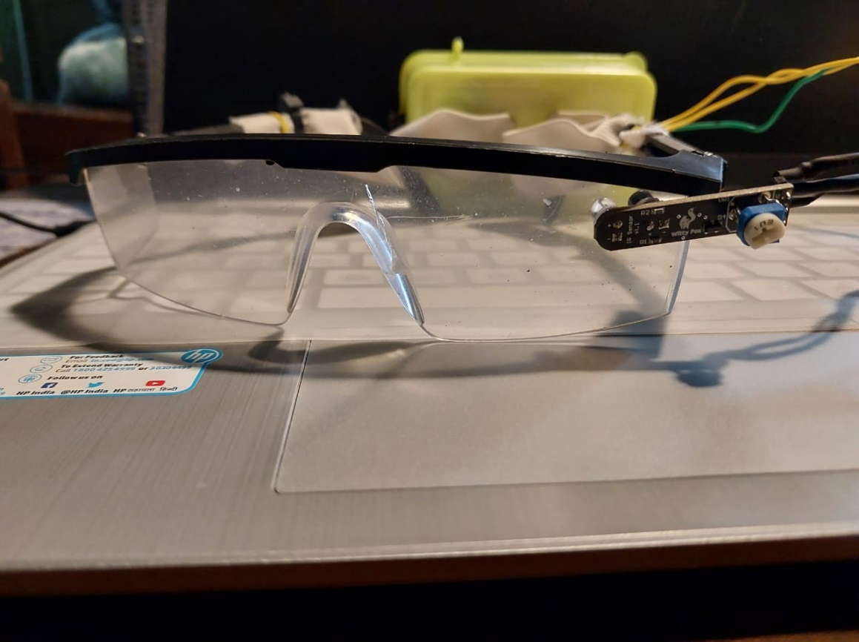

**Fig.1-Assembled Project**

**2.5 WORKING**

In this project, we have used an I-R sensor with LEDs, Arduino Nano, Buzzers, a Vibration motor, Battery of 9 Volts all these components are connected and the IR Sensor Module is fixed to the glass.

I-R Sensor’s first pin (out) is connected to Arduino Nano’s A0; the Second pin(GND) ground is connected to the GND of Arduino and the third pin which is Vcc of IR sensor is connected to 5V of Arduino Nano.[2]

Arduino Nano’s first pin (Vin) Voltage input is connected to the positive(+ve) of the Battery through an SPST switch and GND is connected to the negative(-ve) of the battery.

The buzzers’ and LED’s positive pin is connected to Arduino’s D13 pin and the negative pin is connected to the GND of Arduino nano and the battery.

The vibration motor’s positive pin is connected to Arduino’s D3 pin and the negative pin is connected to the GND of Arduino nano and the battery.

The Goggles detect the sleep of a person and alert him by the sound of a buzzer and vibration of the vibration motor. If the person is feeling drowsy while driving a car or bike and the person can’t control himself and he/ she slept more than 1.5 sec then the IR detects the eyes and pass the connection to the buzzer alerting the person at buzz till the person wakes up.

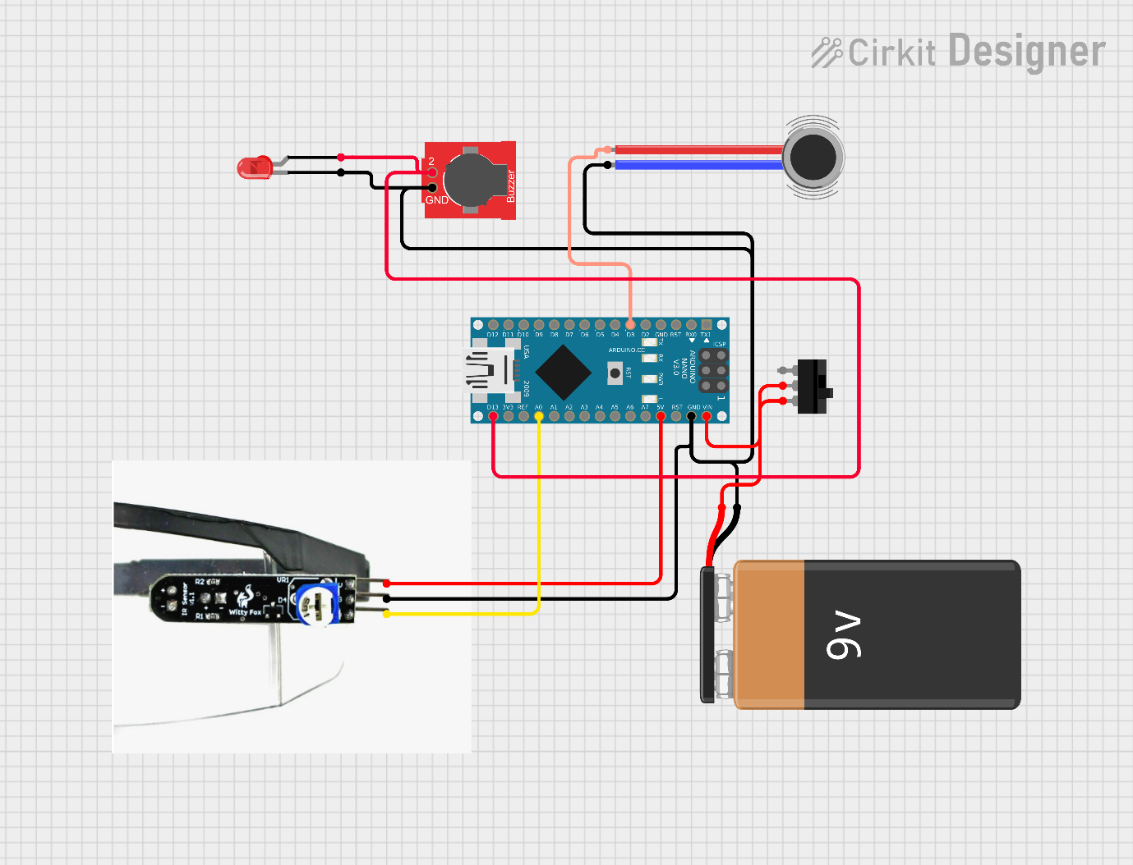

**Fig.2-Circuit diagram**

Here,

VB1 is Vibrator Motor

L1 is an LED light

B1, and B2 are 2 buzzer

**2.6 ALGORITHM OF THE ARDUINO PROGRAM**

1. Define constants for the IR sensor and the buzzer.
2. In the setup function:

a. Set the IR sensor pin as an input. Set the second LED pin as an output.

c. Set the built-in LED pin as an output.

d. Set the vibration pin as an output.

1. In the loop function:

a. Check if the IR sensor is detecting an object.

b. If the sensor is HIGH (i.e. detecting an object):

i. Wait for 1.5 seconds to make sure the object is still there.

ii. Check if the sensor is still HIGH after the delay.

iii. If the sensor is still HIGH, turn on the built-in LED, and turn on the second LED and the buzzer, and the vibrator.

iv. If the sensor is no longer HIGH, turn off the built-in LED and the second LED and the buzzer, and the vibrator.

c. If the sensor is not HIGH (i.e. not detecting an object), turn off the built-in LED and the second LED and the buzzer, and the vibrator.

**CONCLUSIONS**

Drowsiness detection is used to detect drowsiness quickly. This system prevents the driver from falling asleep while driving. The buzzer alerts the driver if the eyes are closed for a period that can be set in the code. This paper is intended to protect drivers from drowsiness-related accidents. It applies to all types of vehicles. This system can be used in both cars and motorcycles. It may concentrate on the use of other external factors such as sleeping hours, vehicle state, weather conditions, and mechanical data for fatigue measurements.

**REFERENCES**

1. ANTI SLEEP ALARM PROJECT USING EYE BLINK SENSOR & ARDUINO

<https://circuitsbazaar.com/anti-sleep-alarm-project-using-eye-blink-sensor/>

1. Driver Drowsiness Detection Systems

Authors: Damian Sałapatek. Jacek Dybała, Paweł Czapski, Paweł Skalski

<https://www.researchgate.net/publication/319464008_Driver_Drowsiness_Detection_Systems>

1. Fall asleep-<https://forum.arduino.cc/t/fall-asleep/123690>